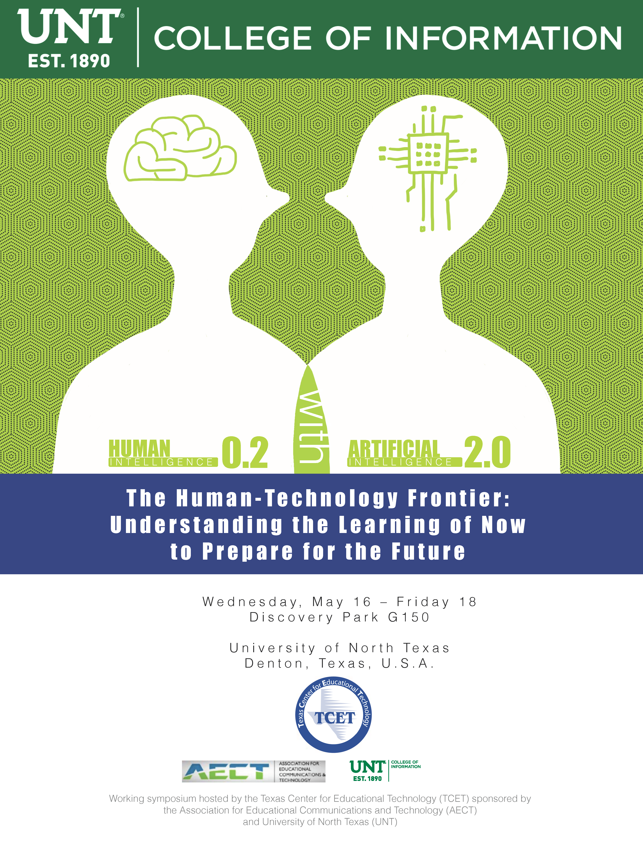

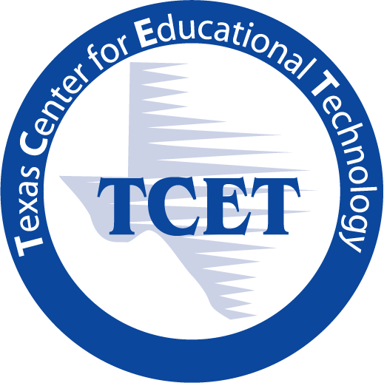
Human Intelligence 0.2 with Artificial Intelligence 2.0

Understanding the Learning of Now to Prepare for the Work of Future

University of North Texas Discovery Park G150, Denton, Texas, U.S.A.
Wednesday, May 16 – Friday 18
Organizers: Dr. Lin Lin, Professor, UNT (Lin.Lin.unt.edu)
Dr. J. Michael Spector, Professor, UNT (Mike.Spector@unt.edu)

Overview
The Texas Center for Educational Technology (TCET) is hosting a working symposium with distinguished scholars on May 16 – May 18, 2018. The symposium is sponsored by the Association for Educational Communications and Technology (AECT) and University of North Texas. The purpose of this working symposium is to generate short-term and long-term collaboration goals and plans to revive TCET as a Research and Development center for educational technologies in Texas. Distinguished scholars will focus on the learner as a whole person, with healthy development of brain, habit, behavior, and learning in the fast-advancing technological world. The general format of each day will feature short and provoking presentations each morning and afternoon, followed by small group activities around key topics.

Goals and Deliverables
Through collaboration with local universities, schools, and agencies and through an expanded partnership with global collaborators including universities and business partners internationally, we will re-establish TCET as the Research and Development Center for learning and teaching technologies in Texas. Concrete deliverables include an edited volume with the Symposium participants and partners, along with collaborative projects and grant proposals to continue research and development in areas of high interest to our participants and partners.

Background
One of the big ideas proposed by the National Science Foundation is "The Future of Work at the Human-Technology Frontier." The four core research themes proposed by NSF are: 1) Building the human-technology partnership; 2) Augmenting human performance; 3) Illuminating the socio-technological landscape; 4) Fostering lifelong learning. This working symposium addresses some of these issues. The key discussion topics include:
- Learning and human intelligence: What are the fundamental problems with regard to learning and education? What do the history and future of learning look like? Based on what we know of the brain and what we are likely to understand in near future, how should learning be defined/redefined?
- Towards a holistic account of a person – brain, body, habits, and environment: How do people typically develop over time and with experience? How do researchers in different disciplines typically frame learning research and which ones have embraced a holistic approach? What would a research design that embraces a whole person perspective look like? Share examples.
- Human intelligence with innovations and advances of technologies: What technologies are most likely to have a positive impact on learning in the next 2 years? 5 years? 10 years? What are the most challenging problems confronting effective use of advanced technologies today? What challenges are likely to emerge in the next 2 to 5 years?
- Properties and units of measures of learning: What are the constructs of learning given the multilevel technologies, collaborative networks, methodologies, and analysis techniques we have to work with?
- Fragmented relationship among theory, research, practice and policy: What examples of effective alignment link behavioral, cognitive and neurological science, learning research, instructional practice, and educational policy? What might be done in the next 2 to 5 years to improve those links?
- What would a reasonable research agenda be for an organization like TCET? What can we do together – publish, present, conduct research and development?
Wednesday, May 16, 2018, Discovery Park G150 Agora, Morning Sessions
Time |  | Activities | Speakers and/or Facilitators
08:30 - | 09:00 | Breakfast
09:00 - | 09:05 | Introductions | Dr. Kinshuk, Professor  Dean, College of Information, UNT
09:05 - | 09:15 | Opening Remarks | Dr. Neal Smatresk  President, UNT
09:15 - | 09:20 | TCET Symposium Goals and Expected Outcomes | Dr. Lin Lin, Professor  Dr. J. Michael Spector, Professor  UNT
09:20 - | 09:40 | TCET Foundation and History | Dr. James Poirot  Professor Emeritus, UNT
09:40 - | 10:00 | Panel Discussions: the Future of TCET | Drs. James Poirot; Cathleen Norris; Elliot Soloway; and J. Michael Spector  UNT and University of Michigan
10:00 - | 10:10 | Coffee Break
10:10 - | 10:40 | Networking Activities | All
10:50 - | 11:05 | Toward a Neuro-Cognitive Redefinition of Learning | Dr. Phillip Harris  Executive Director, AECT
11:05 - | 11:25 | Discussions | Dr. Brad Hokanson  Professor, University of Minnesota  Past President, AECT
Lunch
11:30 - | 13:30 | Lunch: Discovery Park G150 Agora  Please visit: Students’ poster presentations and NetDragon virtual reality games (Location: Discovery Park Library)

Wednesday, May 16, 2018, Discovery Park G150 Agora, Afternoon Sessions
Time |  | Activities | Speakers and/or Facilitators
01:30 - | 01:45 | Defining the “NEW” K12 Digital Ecosystem | Mr. Lenny Schad  Chief Technology Information Officer  Houston Independent School District
01:45 - | 02:10 | Discussions | Dr. Elliot Soloway  Professor, University of Michigan
02:20 - | 02:35 | Artificial Intelligence 2.0 and Education | Dr. Ronghuai Huang  Professor, Dean, Smart Learning Institute, Beijing Normal University
02:35 - | 2:55 | Discussions
02:55 - | 03:05 | Coffee break
03:05 - | 03:20 | The Role of Digital Curricula in K-12 | Dr. Cathleen Norris  Regent Professor, LT Chair, UNT  Dr. Elliot Soloway  Professor, University of Michigan
03:20 - | 03:40 | Discussions
03:50 - | 04:05 | The Challenges of Sustaining a 1:1 Tech Initiative in Upper Elementary Classrooms | Ms. Elizabeth Fuentes  Senior Education Grants Coordinator  Ms. Tina Chong  Education Program Manager  Jiv Daya Foundation
04:05 - | 04:25 | Discussions | Dr. Cathleen Norris  Regent Professor, LT Chair, UNT
04:35 - | 04:50 | Intelligent Textbook for Critical Thinking in Biology | Dr. Vinay K. Chaudhri  Visiting Professor  Stanford University
04:50 - | 05:10 | Discussions | Dr. Rodney Nielsen  Associate Professor, CS, UNT
05:20 - | 05:35 | Summary and Reflection | Dr. J. Michael Spector and Dr. Lin Lin
Dinner
06:00 - |  | Dinner: GreenHouse Restaurant & Bar
 |  | Address: 600 N Locust St, Denton, TX 76201; Phone: (940) 484-1349

Thursday, May 17, 2018, Discovery Park G150 Agora, Morning Sessions
Time |  | Activities | Speakers and / or Facilitators
08:30 - | 09:00 | Breakfast
09:00 - | 09:15 | Review and overview | Dr. J. Michael Spector and Dr. Lin Lin
09:20 - | 09:35 | Creativity and Measurement | Dr. Brad Hokanson  Professor, University of Minnesota  Past President, AECT
09:35 - | 09:55 | Discussions | Dr. Phillip Harris  Executive Director, AECT
10:05 - | 10:20 | Learning Paths and Analytics | Dr. George Siemens  Director, Learning Innovations and Networked Knowledge Research Lab University of Texas at Arlington
10:20 - | 10:40 | Discussions
10:40 - | 10:50 | Coffee Break
10:50 - | 11:05 | Data-Driven Education: The Next Great Frontier or a Pipe Dream? | Mr. William Zhou  CEO and Co-founder, Chalk
11:05 - | 11:25 | Discussions | Dr. George Siemens  Director, Learning Innovations and Networked Knowledge Research Lab University of Texas at Arlington
11:35 - | 12:00 | Networking Activities
Lunch
12:00 - | 01:30 | Lunch: Discovery Park G150 Agora

Thursday, May 17, 2018, Discovery Park G150 Agora, Afternoon Sessions
Time |  | Activities | Speakers and/or Facilitators
01:30 - | 01:45 | The Neuroscience of Learning | Dr. Marc Schwartz  Professor  University of Texas at Arlington
01:45 - | 02:05 | Discussions | Debbie Cockerham  PhD Candidate; Managing Director  Research Learning Center, FWMSH
02:15 - | 02:30 | Neuropsychological Assessment 3.0 | Dr. Thomas D. Parsons  Director of NetDragon Digital Research Centre  Professor, Director of Computational Neuropsychology and Simulation
02:30 - | 02:50 | Discussions
02:50 - | 03:00 | Coffee Break
03:00 - | 03:15 | Brain Initiative, M2lab and Critical Thinking Project | Dr. Xiaoqing Gu  Professor and Dean  Dr. Jing Leng  Assistant Professor  School of Education Science  East China Normal University
03:15 - | 03:35 | Discussions | Dr. J. Michael Spector  Professor, UNT
03:45 - | 04:05 | Innovative and Effective Learning: Focusing on a Developmental Approach to Critical thinking | Dr. J. Michael Spector  Professor, UNT
04:05 - | 04:25 | Discussions | Dr. Xiaoqing Gu  Professor and Dean, ECNU
04:35 - | 05:00 | Summary and Reflection Tomorrow’s Agenda
Dinner
06:00 - |  | Dinner: Texas Roadhouse: Steakhouse
 |  | Address: 2817 S Interstate 35 E, Denton, TX; 76205 Phone: (940) 243-7427

Friday, May 18, 2018, Discovery Park G150 Agora, Morning Sessions
Time |  | Activities | Speakers and / or Facilitators
08:30 - | 09:00 | Breakfast
09:00 - | 09:30 | Review and Overview
09:30 - | 09:45 | Learning Analytics and Logic Models (virtual) | Dr. Dirk Ifenthaler  Professor and Chair of Learning, Design and Technology at University of Mannheim  Editor-in-Chief, Technology, Knowledge and Learning
09:45 - | 10:05 | Discussions
10:05 - | 10:15 | Coffee break
10:15 - | 10:30 | Dignation for TCET (virtual) | Dr. Gary Natriello  Professor, Director, Gottesman Libraries  Executive Editor, Teachers College Record  Dr. Hui Soo Chae  Director, Research and Development for the EdLab and the Gottesman Libraries  Teachers College, Columbia University
10:30 | 10:50 | Discussions
11:00 | 11:30 | Wrap-up Discussions | Dr. J. Michael Spector, Professor  Dr. Lin Lin, Professor  UNT
Lunch
11:30 |  | Lunch Box  Discovery Park G150 Agora

